Pengajuan Dana

1. Towing Mercy C300 2023 Hitam DT 888 (via telfon)
2. 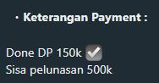Cek Rubicon 2011 Orange Orange BH 1408 WM

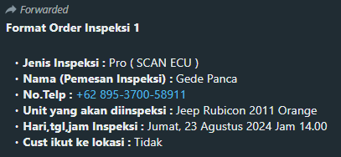

1. 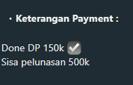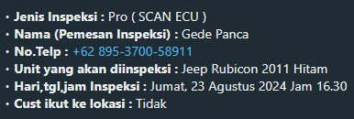Cek Rubicon 2011 Orange Hitam B 568 ALD
2. 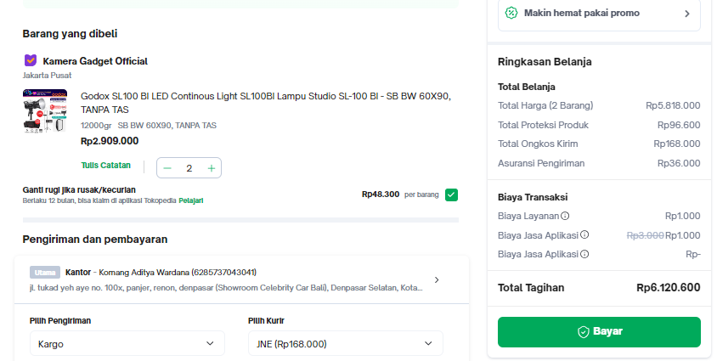Content (godox lampu)